7th Grade Science: Final Exam Study Guide

Nature of Science
- DEFINE and GIVE AN EXAMPLE of each of the following terms:
  - Theory:

  - Law:

  - Hypothesis:

  - Inferences:

  - Data:

  - Prior Knowledge:

Characteristics of Life and The Cell (Chapter 2 and 4)
- What are the six characteristics of life?
  - All living things have _____________.
  - Living things respond to ______________ in the ________________.
  - Living things produce _________________ like themselves.
  - All living things have __ __ __.
  - Living things use _________________ to carry out the daily activities of life.
  - Living things ______________ and _____________.

- What are some major differences between prokaryotic and eukaryotic cells?

- What is an organelle?
- Complete the table by either describing the function of the organelle or by giving the name of the organelle that fits the description of the function given. Also indicate whether the organelle can be found in animal cells only, plant cells only or both.

Organelle | Function | Found in Plant or Animal cells? Or Both?
Nucleus
 | Energy producing cell. This is where ATP is made.
 | The protein factories of the cell.
Chloroplasts

Lysosomes

 | This is the packaging center of the cell. Proteins are packaged and distributed here.
Endoplasmic Reticulum

Vacuole

Cell Wall

- Be able to identify and label the parts of the cell. 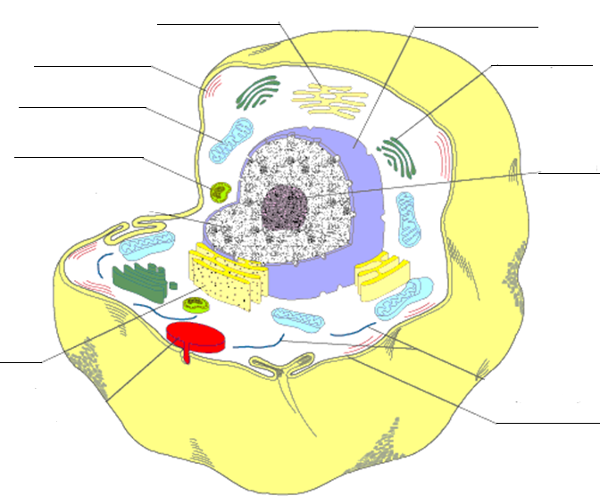

Cellular Transport and Exchange (Chapter 5)
- What is diffusion?

- What is osmosis?

- What is the difference between active transport and passive transport?

- What is the molecule of energy called?

- In which organelle does cellular respiration occur (i.e. in which organelle is energy produced/made?)

Mitosis
- What is mitosis?

- List ALL the stages of Mitosis and explain/draw what happens in EACH stage.
Phase (Stage) and a Picture | What’s Happening? (1-2 Sentences)
1.Prophase_______________

2.____________________

3.____________________

4.___________________

5.___________________

6.___________________

- What is meiosis?

- What is the difference between mitosis and meiosis?

Genetics and DNA (Chapter 6 and 7)
- What is heredity?

- Who is considered to be the “Father of genetics” because of his studies on pea plants?

- Define and explain the following terms of genetics:
  - Gene:

  - Allele:

  - Purebred:

  - Hybrid:

  - Dominant allele:

  - Recessive allele:

  - Phenotype:

  - Genotype:

  - Homozygous dominant:

  - Homozygous recessive:

  - Heterozygous:

- Complete the following genetic crosses using a Punnett Square:

- Rr X Rr; R= red hair, and r=blue hair

- YY x yy; Y= yellow eyes; y= purple eyes

- Ss X SS; S = superpower; s = no superpower

- How many pairs of chromosomes do humans have? How many chromosomes in all do humans have?

- Who discovered DNA?

- DNA is made up of subunits called ______________? What are the three components that make up these subunits?

- What are the bases of DNA? WHAT ARE THE BASE PAIRS?

- What is a mutation?

Body Systems
- List the levels of body organization from the smallest to the largest level?

- Explain what the function of the Circulatory System is? Why is it important?

- Explain what the function of the Respiratory System is? Why is it important?

- What is the difference between veins and arteries? What roles do they play in the transport of blood throughout the body?
  - Veins:

  - Arteries:

- What are the four main functions of the skeletal system?

- What is the main function of the muscular system?

- What are the three different types of muscles? Give an example of each.

- What is the difference between voluntary and involuntary muscles? Give an example of each.

Evolution (Chapter 8 and 9)
- Define the following terms:
  - adaptation:

  - species:

  - evolution:

  - fossil record:

- Explain how evolution occurs, specifically through natural selection (what is natural selection?)?

- What are some of the evidences for evolution?

