**Human Body Systems Test Study Guide**

***Directions: Answer the following questions in complete sentences and as thoroughly as possible.***

1. List the levels of body organization from the smallest to the largest level?
2. Explain what the function of the Circulatory System is? Why is it important?
3. Explain what the function of the Respiratory System is? Why is it important?
4. What is the difference between veins and arteries? What roles do they play in the transport of blood throughout the body?
   1. Veins:
   2. Arteries:
5. What is blood made up of? What are the 4 different components?
6. List the pathway of the blood starting with the inferior and superior vena cava.
7. Label the following parts of the heart:

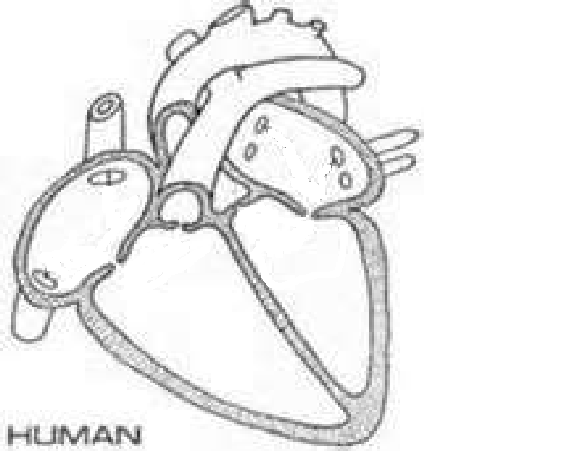

15.

11.

12.

13..

14..

10.

1. 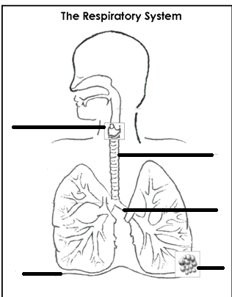Label the following parts of the respiratory system:
2. What are the four main functions of the skeletal system?
3. What’s the difference between **compact bone** and **spongy bone?**
4. What is **cartilage**?
5. What is a **joint?**
6. What are the different types of joints, what range/types of motion do they usually allow and what parts of the body are they usually found in?
   1. **Ball and socket joint:**
   2. **Gliding joint:**
   3. **Fixed joint:**
   4. **Pivot joint:**
   5. **Hinge joint:**
7. What is the difference between a **ligament** and **tendon?**
8. What is the difference between a **sprain** and a **strain?**
9. What is the difference between **voluntary** and **involuntary** muscle?
10. Describe the following three types of muscle and where they can be found:
    1. **Cardiac:**
    2. **Smooth:**
    3. **Skeletal:**
11. Explain how muscles move (what must they do in order to move a limb for example?)
12. Explain what muscle **antagonistic pairs** are?
13. Define the following:
    1. Flexor:
    2. Extensor:
14. Be able to label the following muscles on the body: *quadriceps, latissimus dorsi, biceps brachii, triceps brachii, pectoralis major, rectus abdominis, external obliques*

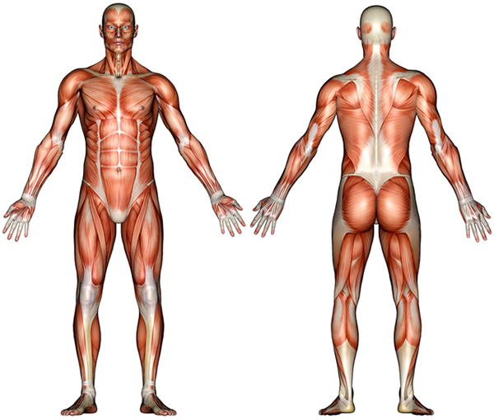

1. Label the following parts of the eye: *cornea, iris, pupil, retina, optical nerve, lens*

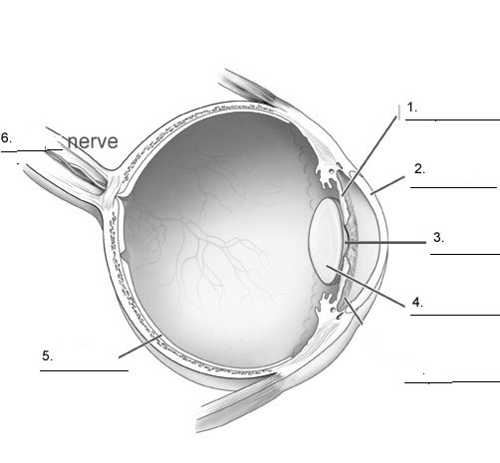

1. Explain how the eye sees.
2. Explain the role of light in sight.
3. Distinguish/explain the difference between the following two types of photoreceptors:
   1. Rod cells:
   2. Cone cells: