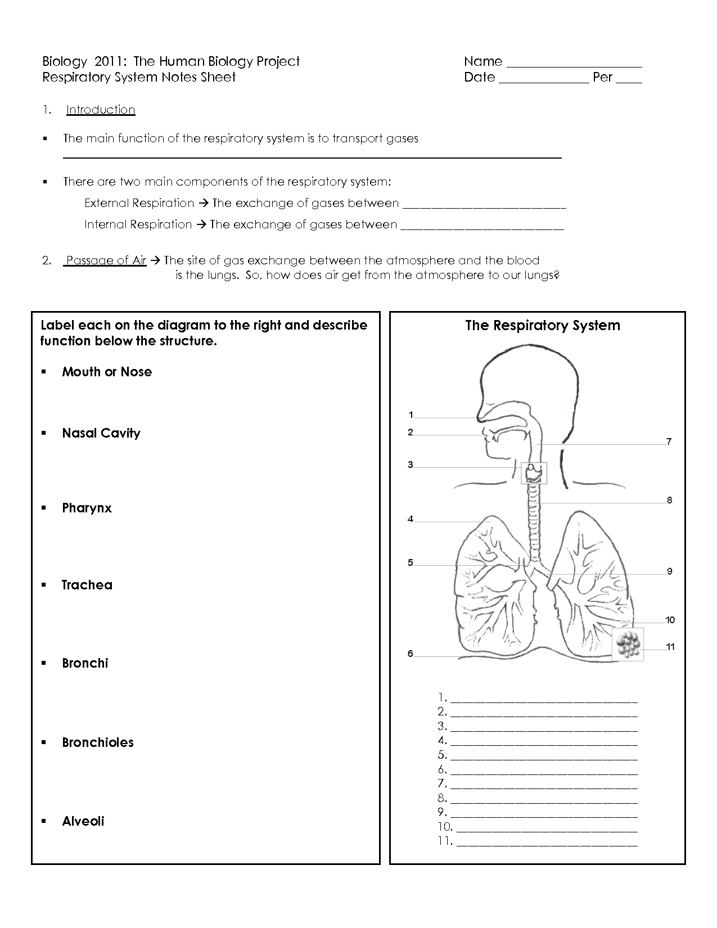

Gas Exchange Once air is inside the lungs, gases are exchanged between the alveoli and the blood in the capillaries.
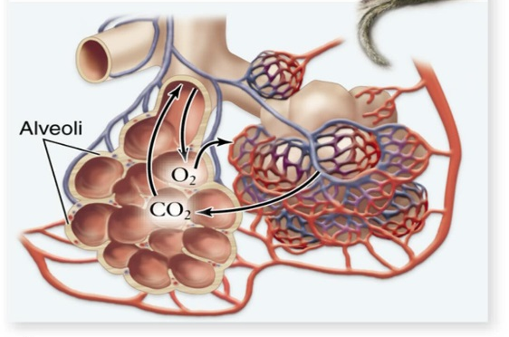
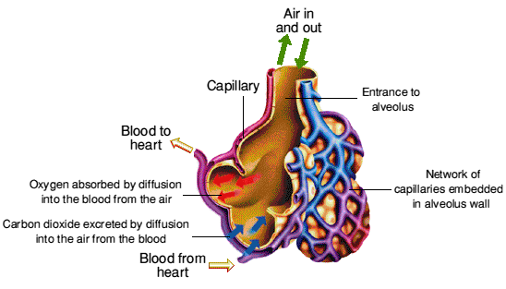

- Oxygen
  - What happens to Oxygen in lungs? (Describe in detail)

  - What happens to Oxygen in body tissue? (Describe in detail)

- Carbon Dioxide
  - What happens to Carbon Dioxide in lungs? (Describe in detail)

  - What happens to Carbon Dioxide in body tissue? (Describe in detail)

Breathing Mechanism Breathing is the process of moving air into and out of the lungs.
For each process below, explain the order of operation. (Steps from start to finish)
Inspiration

Expiration

Regulation (What regulates and how?)

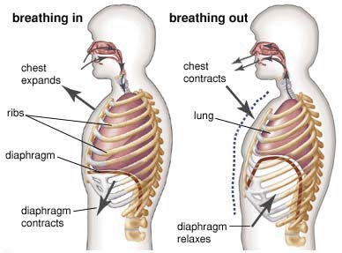

Problems with the Respiratory System
- We know the Respiratory System exchanges gases (oxygen and carbon dioxide) with the atmosphere. What else can enter and exit the body using respiration? (Make a list and describe each).

- Gather research on the diseases below and describe each in detail (Please include source of information. Continue on the back, if necessary!)
  - Pneumonia

  - Emphysema

  - Cystic Fibrosis

  - Asthma

Critical Thinking
- Why does a single-celled organism not need a respiratory system? Explain!

